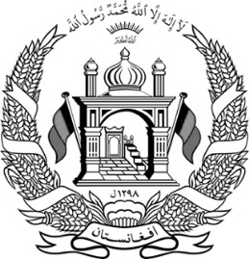

Islamic Republic of Afghanistan
Ministry of Interior Affairs
Department of Population Statistics
Number:
Identification
Name
Father’s Name
Grand Father’s Name
Place of Birth
Ethnicity
Occupation
Gender
Marital Status
Date of Birth
Physical Characteristics
Height | Medium
Color of eye | Hazel
Color of skin | Wheaten
Color of hair | Black
Other sings
Fingerprint/signature
Place of Registration
Province
District
Sector
Village
Street name
Home number
Volume number
Page number
Registration number
Issue date
ID number of head or member of the family (Father)
Volume number
Page number
Registration number

Mr/Ms. XXXX, whose identification is written in this national identification document, is a citizen of Afghanistan; so, this ID (Tazkira) is issued to her by the 3rd sector statistics office.

Signature of Registerer Signature of Chief Officer

